“Web Development”

## Acacious Technologies .

**A Training Report**

Submitted in partial fulfillment of the requirements for the award of degree of

## Master of Computer Application (MCA)

(Specialization – Web Development)

Submitted to:

# Lovely Professional University

Phagwara (Punjab)



## From – 04/04/2024 to 04/10/2024

Submitted By: Submitted to:

**Harsh Raj Singh Dr. Prience Arora**

Reg. No.- 12211069 (Internal Mentor)

# To whom so ever it may concern

This is to certify that **Harsh Raj Singh**, Reg. Number – **12211069** from **Lovely Professional University, Phagwara, Punjab**, is working as a trainee in **Acacious Technologies, Noida , U.P** on **“Web Application”** under my supervision from **Apr, 2024**.

It is further stated that the work carried out by the student is a record of original work to the best of my knowledge for the partial fulfillment of the requirements for the award of the degree, **Master of Computer Application (MCA)**.

External Supervisor: Internal Supervisor :

# Mr. Abhishek Kumar Singh Dr. Prience Arora

( Sr Software Developer) (Placement Mentor)

# To whom so ever it may concern

I, **Harsh Raj Singh** , Registration Number - **12211069**, hereby declare that the work done by me on **“Implementation of Various Web Applications”** from **apr 2024** under the supervision of **Mr. Abhishek Kumar Singh,** , Sr,Software Developer**, Acacious Technologies, Noida , U.P** and **Dr. Prience Arora Placement Mentor, Lovely professional University, Phagwara, Punjab**, is a record of original work for the partial fulfillment of the requirements for the award of the degree, **Master of Computer Application (MCA)**.

# Harsh Raj Singh

Registration Number – 12211069



**ACKNOWLDGEMENT**

The internship opportunity I had with Acacious Technologies was a great chance for learning and professional development. Therefore, I consider myself as a very lucky individual as I was provided with an opportunity to be a part of it. I am also grateful for having a chance to meet so many wonderful people and professionals who led me though this internship period.

Bearing in mind previous I am using this opportunity to express my deepest gratitude and special thanks to the Mr. Abhishek Kumar Singh, Sr Software Developer who in spite of being extraordinarily busy with his duties, took time out to hear, guide and keep me on the correct path and allowing me to carry out my project at their esteemed organization and extending during the training.

I express my deepest thanks to Mr. Sarabjit Kumar (Placement Co-ordinator) for taking part in useful decision & giving necessary advices and guidance and arranged all facilities to make life easier. I choose this moment to acknowledge his contribution gratefully.

Harsh Raj Singh

12211069

# Table of Content

|  |  |  |
| --- | --- | --- |
| **S.No.** | **Title** | **Page No** |
| 1. | Declaration by Supervisors | 2 |
| 2. | Declaration by Student | 3 |
| 3. | Training Certification from organization | 4 |
| 4. | Acknowledgement by student | 5 |
| 5. | Table of Contents | 6 |
| 6. | Introduction of the Company | 7-8 |
| 7. | Profile of the Problem | 9-11 |
| 8. | Introduction to existing system | 12-15 |
| 9. | Problem Analysis | 15-18 |
| 10. | Approach to resolve it | 18-19 |
| 11. | Feasibility Study | 20-21 |
| 12. | Software Requirements | 21-22 |
| 13 | Project details | 23-27 |
| 14. | Structural Testing | 28-30 |
| 15. | Brief description of work done | 30 |
| 16. | CA for INTERNSHIP | 31-35 |

**Introduction to Company**

**ACACIOUS TECHNOLOGIES**

Acacious Technologies is a privately held Web Designing And Development Company in India, which offers solutions for helping small scale, medium-sized and large scale enterprises to navigate the digital revolution. We have rich experience in creating custom software and IT software systems that can embark your online business journey to the next level.

Our company is a solid technology foundation. Team of 5 years of expert technical professionals. Client satisfaction is our first priority.

24*7 customer support is available. Work on smooth flywheel methodology. Seamless communication with clients.

Web Design and Development Services in India, and other countries help you to grow your business in a unique manner. We strive hard to develop the finest IT solutions that will let you interact with your customers and mark your presence everywhere. We render pixel- perfect web designs that help you build your brand. Working on the

motto that a website is not something that just ends up with .com or

.in, but it should ultimately bring success to you, we cater to your entire requirements of web design, web development, mobile app development, and digital marketing too. So, if you want to design and develop a website that is fused with creativity, discuss your project idea with us!

Being a leading IT Company in India, ACACIOUS delivers

innovative solutions to clients all around the world. Our company collaborates with different technology partners to serve our customers with exactly what they need! We work on the objective to render value-adding solutions to our valuable clients on a global basis.

# Profile of the Problem

During my industrial training at Acacious , I was tasked with developing two web applications: a school management system and a real estate web application. The primary problem was to create responsive, user-friendly, and efficient web applications that cater to the specific needs of educational institutions and real estate businesses. This report details the challenges, objectives, and solutions implemented during the development process.

The school management system aimed to address the numerous administrative challenges faced by educational institutions, including managing student data, tracking attendance, scheduling classes, and communicating with parents. The objective was to create a comprehensive system that streamlined these processes, making them more efficient and accessible. On the other hand, the real estate web application sought to provide an effective platform for listing properties, providing detailed property information, facilitating communication between buyers and sellers, and managing property transactions. The goal was to develop a user-friendly application that enhanced the property search experience and simplified the transaction process.

For the school management system, the primary objectives were to develop an efficient data management system, implement an attendance tracking feature, create a module for scheduling classes and managing timetables, enable seamless communication between teachers, students, and parents, and ensure secure access control for different user roles such as admin, teacher, student, and parent. For the real estate web application, the objectives included designing an intuitive

interface for property listings with detailed information, implementing advanced search filters to help users find properties that match their criteria, allowing users to create profiles to save searches, favorite properties, and receive notifications, providing messaging and contact features for buyers and sellers to communicate, and developing a module to manage property transactions and track the status of deals.

The development process was not without its challenges. Technical challenges included ensuring the applications were fully responsive and functional across different devices and screen sizes, optimizing the applications for fast loading times and efficient performance, and implementing robust security measures to protect user data and prevent unauthorized access. User experience challenges involved designing user-friendly interfaces that were easy to navigate for users with varying levels of technical expertise, seamlessly integrating multiple features and functionalities without overwhelming the user, and ensuring the applications were accessible to users with disabilities, adhering to accessibility standards.

To address these challenges, several solutions were implemented. For the school management system, a relational database was utilized to store and manage student, teacher, and staff data, with CRUD (Create, Read, Update, Delete) operations to maintain data integrity. An attendance module with real-time tracking and reporting features was developed, allowing teachers to mark attendance digitally and parents to receive instant notifications of absences. A dynamic scheduling module was created, allowing administrators to easily create and modify timetables, with integrated calendar views for better visualization. A

messaging system was implemented for teachers, students, and parents, with notification features for important announcements and updates. Additionally, a role-based access control system was developed to ensure secure access for different user roles, with each role having specific permissions tailored to their needs.

For the real estate web application, a user-friendly interface for property listings was designed, with comprehensive details including images, descriptions, and location maps, and a content management system (CMS) was integrated for easy updates. Advanced search filters were implemented, allowing users to search by location, price range, property type, and amenities, with a map-based search option for enhanced user experience. User profiles were enabled, allowing users to create accounts, save searches, favorite properties, and receive notifications on new listings and price changes. Messaging and contact forms were integrated for buyers and sellers, enabling direct communication through the platform to streamline inquiries and negotiations. A transaction management module was developed to track the status of property deals, with features for digital document signing and secure payment processing.

In conclusion, the development of the school management system and the real estate web application during my industrial training at Acacious presented a unique set of challenges and opportunities. By focusing on responsiveness, performance, security, and user experience, I was able to create efficient, user- friendly web applications that cater to the specific needs of educational institutions and real estate businesses. The successful implementation of these projects provided valuable insights and enhanced my skills as a web developer.

# Introduction to Existing Systems

In many educational institutions, existing systems for managing administrative tasks such as student data, attendance, and communication are often reliant on manual processes or outdated software. These systems typically involve extensive paperwork and manual entry, leading to significant inefficiencies and a higher likelihood of errors. For example, student records are often maintained in physical files or spreadsheets, which are cumbersome to update and difficult to search through when quick access to specific information is needed. Attendance is commonly tracked using paper registers or basic software that lacks real-time updating and integration with other school systems. This manual approach not only consumes a considerable amount of time for teachers and administrative staff but also poses challenges in maintaining data accuracy and consistency.

Furthermore, communication between teachers, students, and parents in many schools is still predominantly handled through traditional means such as printed notices, phone calls, and face-to-face meetings. This method of communication can be slow and unreliable, especially when timely updates are crucial. The lack of a centralized system for managing communication often leads to miscommunications and delays, impacting the overall efficiency of the school’s operations.

Similarly, real estate businesses often rely on traditional methods for listing properties, tracking leads, and managing client interactions. Property listings are frequently managed through physical brochures, newspapers, or non-specialized digital platforms that do not offer advanced search capabilities or detailed property information. Potential buyers or renters must contact real estate agents directly to inquire about properties, leading to an inefficient and time-consuming process. Agents, in turn, have to manually track leads and follow up with clients, often using simple spreadsheets or paper records. This manual tracking system is prone to human error, leading to missed opportunities and loss of potential sales.

Additionally, client interactions and transactions in the real estate industry often involve a significant amount of paperwork, including contracts, disclosures, and other legal documents. These documents are usually handled in person or through postal services, which can cause delays and increase the risk of documents being lost or damaged. The lack of digital transaction management systems means that tracking the progress of deals and ensuring all necessary steps are completed can be a cumbersome process.

Both educational institutions and real estate businesses face a significant challenge in integrating modern technologies into their existing systems. Outdated software solutions in schools are often not designed to handle the complexities of contemporary educational administration, such as real-time data updates, comprehensive analytics, and integrated communication tools. In the real estate sector, traditional methods do not provide the level of detail and

immediacy that modern buyers and renters expect, nor do they support the streamlined, efficient processes that agents need to stay competitive in a fast- paced market.

The reliance on manual processes and outdated systems in both sectors not only hinders operational efficiency but also affects user experience. In educational institutions, students, parents, and teachers find it difficult to access and share information quickly and efficiently. In the real estate industry, potential buyers and renters experience frustration due to the lack of immediate access to detailed property information and the slow pace of transactions.

Moreover, these traditional systems are not scalable. As schools and real estate businesses grow, the volume of data and the complexity of managing it increases exponentially. Without modern, scalable solutions, these institutions struggle to keep up with the demands of growth. In schools, this can mean that valuable educational resources are diverted towards administrative tasks rather than being focused on improving student outcomes. In real estate, it means that agents spend more time on administrative work than on building client relationships and closing deals.

In summary, the existing systems in educational institutions and real estate businesses are characterized by manual processes and outdated software that are inefficient, error-prone, and lacking in integration with modern technologies. These systems create significant operational challenges, hinder scalability, and

negatively impact user experience. There is a clear need for innovative solutions that leverage modern technology to streamline processes, enhance efficiency, and improve overall effectiveness in both sectors. The development of responsive, user-friendly, and efficient web applications tailored to the specific needs of these industries represents a critical step towards addressing these challenges and transforming their operational capabilities.

**PROBLEM ANALYSIS**

### School Management System



In many educational institutions, the reliance on manual processes for managing administrative tasks leads to significant errors and inefficiencies. Tasks such as recording student attendance, maintaining grade books, scheduling classes, and managing communication between teachers, students, and parents are often performed manually or with outdated software. These methods are not

only time-consuming but also prone to human error, resulting in inaccurate records and miscommunication. For instance, manually tracking attendance can lead to errors in recording, while paper-based grade books are difficult to update and prone to damage or loss. The lack of a centralized platform further exacerbates these issues, as information is scattered across different systems and formats, making it difficult to access and manage efficiently. Teachers and administrators spend a considerable amount of time on administrative tasks, detracting from their primary focus on education and student engagement. This decentralized approach also hampers the ability to generate comprehensive reports and analytics that can inform decision-making and improve educational outcomes.

### Real Estate Web Application

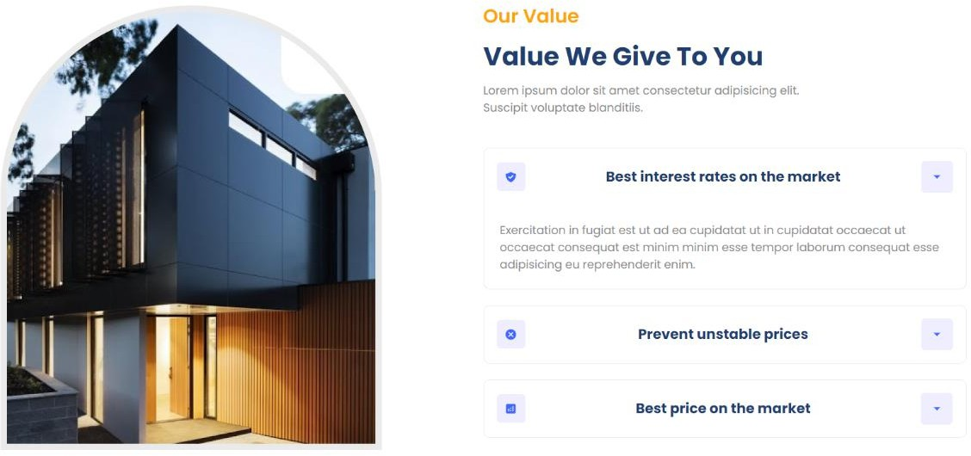

The real estate industry similarly suffers from inefficiencies due to traditional methods of listing and managing properties. Property listings are

often handled through physical brochures, newspaper ads, or basic digital platforms that do not offer comprehensive search functionalities or detailed property information. This approach is not only time-consuming for real estate agents but also inconvenient for potential buyers and renters who must sift through various sources to find relevant properties. The process of tracking client interactions and managing leads is also cumbersome. Agents typically use spreadsheets or paper records to track potential clients, which can lead to lost or overlooked leads due to human error. This manual tracking system makes it challenging to follow up with clients in a timely manner, potentially resulting in missed sales opportunities. Additionally, traditional methods do not support the seamless communication and transaction management needed to keep up with the fast-paced real estate market. Without modern tools to automate and streamline these processes, real estate agents struggle to maintain efficiency and provide a satisfactory client experience.

Both the school management system and the real estate web application face significant challenges due to their reliance on outdated methods. The absence of centralized, automated systems in schools leads to administrative inefficiencies and hinders the overall educational experience. In the real estate sector, traditional methods slow down the process of listing and managing properties, making it difficult for agents to effectively track and engage with clients. These challenges highlight the need for modern, integrated solutions that can streamline operations, reduce errors, and enhance the user experience in both industries. By implementing advanced web applications, educational institutions

and real estate businesses can achieve greater efficiency, accuracy, and scalability, ultimately leading to improved outcomes and satisfaction for all stakeholders involved.

**APPROACH TO RESOLVE IT**

### School Management System

**Thorough Analysis:** Conducted a detailed analysis of existing manual and outdated systems to identify critical areas for improvement.

**Centralized Platform Design:** Designed a centralized, web-based platform to consolidate all school-related activities.

**Modern Technologies:** Utilized HTML, CSS, JavaScript, and React.js for development.

**User-Friendly Interface:** Ensured the platform is intuitive and easy to navigate for teachers, students, and parents.

**Digital Attendance:** Implemented real-time digital attendance tracking with instant notifications to parents.

**Dynamic Scheduling:** Developed a flexible class scheduling module for easy timetable creation and modification.

**Integrated Communication:** Added messaging and notification tools for seamless interaction among stakeholders.

**Scalability:** Designed the system to be scalable, accommodating growing data and user needs without performance issues.

### Real Estate Web Application

**Detailed Analysis:** Analyzed traditional methods for listing properties, tracking leads, and managing client interactions to identify inefficiencies.

**Centralized Solution:** Developed a centralized, web-based platform to streamline property listings and client management.

**Modern Technologies:** Employed HTML, CSS, JavaScript, and React.js for the application.

**Comprehensive Listings**: Created an interface for detailed property listings with high-quality images, descriptions, and location maps.

**Advanced Search:** Implemented advanced search functionalities for efficient property filtering by location, price, type, and amenities.

**Lead Management:** Integrated a robust lead management system to track client interactions and follow up on leads promptly.

**Transaction Management:** Included tools for digital document signing and secure payment processing to streamline transactions.

**Responsive Design:** Ensured the platform is responsive, providing a seamless experience across desktops, tablets, and smartphones.

**Scalability:** Designed the system to support increasing numbers of listings and users without compromising performance.

# Feasibility Study

### Technical Feasibility

**Technology Assessment:** Evaluated the proposed technologies (HTML, CSS, JavaScript, React.js) to ensure they could meet the project requirements for developing centralized, responsive, and scalable web applications.

**Compatibility:** Confirmed the compatibility of these technologies with existing infrastructure and their ability to integrate with other systems if needed.

**Resource Availability:** Checked the availability of skilled developers proficient in these technologies and assessed the ease of finding additional resources if necessary.

**Performance and Reliability:** Analyzed the performance and reliability of the chosen technologies to ensure they could handle the anticipated load and provide a seamless user experience.

### Economic Feasibility

**Cost Estimation:** Estimated the overall cost of development, including resources, time, and tools required for both the school management system and the real estate web application.

**Budget Analysis:** Compared the estimated costs with the available budget to ensure the project was financially viable.

**Return on Investment (ROI):** Projected the potential ROI by considering factors such as increased efficiency, reduced operational costs, and enhanced user satisfaction.

**Cost-Benefit Analysis:** Conducted a cost-benefit analysis to weigh the financial benefits against the development and implementation costs, ensuring the investment was justified.

### Operational Feasibility

**User Requirements:** Gathered detailed user requirements through surveys, interviews, and feedback sessions with teachers, students, parents, real estate agents, and clients.

User-Friendly Design: Ensured the system was designed with a user-friendly interface, making it easy for all user groups to navigate and utilize the features effectively.

**Training and Support:** Planned for comprehensive training programs and support resources to assist users in transitioning to the new system and addressing any issues that might arise.

**Scalability and Flexibility:** Ensured the system could scale with growing user bases and adapt to evolving operational needs without significant overhauls.

**Operational Efficiency:** Evaluated the system's ability to improve operational efficiency by streamlining processes, reducing manual tasks, and providing real- time data access and analytics.

By conducting a thorough feasibility study encompassing technical, economic, and operational aspects, we ensured that the proposed solutions for the school management system and the real estate web application were viable and aligned with the project's objectives. This comprehensive approach helped identify potential risks, establish clear benefits, and pave the way for successful implementation.

## Software Requirements

.

**HTML:** Used for structuring the content of the web applications, ensuring a semantic and organized layout.

**CSS:** Employed for styling web pages, including layout design, color schemes, and responsive adjustments to ensure an appealing visual presentation across various devices.

**JavaScript:** Implemented to add interactivity to the web applications, allowing dynamic content updates, form validations, and user engagement features.

**React.js:** Utilized for building user interfaces, facilitating the creation of reusable components, and managing the state of the applications efficiently to enhance performance and scalability.

**VS Code:** Adopted as the primary Integrated Development Environment (IDE) for coding and debugging, offering a wide range of extensions and tools to streamline the development process.

**Online Compilers:** Leveraged for quick code testing and validation, enabling rapid prototyping and immediate feedback during the development phase.

**Brave Browser:** Used for testing and debugging the web applications, ensuring cross-browser compatibility, performance optimization, and secure browsing environments.

These software requirements were chosen to provide a robust, efficient, and developer-friendly environment for creating the school management system and

real estate web application, ensuring the delivery of high-quality, responsive, and scalable solutions.

## Project Details

### School Management Web Page

The school management web page was developed to provide a comprehensive, responsive interface for managing various school activities. The primary focus was on creating a system that could streamline administrative tasks and enhance the overall efficiency of school operations.

**Responsive Interface:** We designed a user-friendly interface that adapts seamlessly to different devices, including desktops, tablets, and smartphones. This ensures that teachers, students, and parents can access the system from anywhere, at any time, enhancing accessibility and convenience.

**Attendance Tracking:** A key feature integrated into the platform is the real- time attendance tracking system. Teachers can quickly mark attendance using digital records, which are instantly updated and stored in a centralized database. Parents receive immediate notifications regarding their child’s attendance, promoting better communication and involvement.

**Grade Management:** Another critical feature is the grade management system. Teachers can enter and update student grades efficiently, with the system automatically calculating averages and generating reports. Students and parents

can view grades and progress reports online, providing transparency and helping identify areas where students may need additional support.

**Class Scheduling:** The web page includes a dynamic scheduling module that allows for easy creation and modification of class timetables. This feature supports real-time updates, ensuring that any changes to the schedule are immediately reflected and communicated to all relevant parties.

Integrated Communication Tools: To facilitate better communication within the school community, we incorporated messaging and notification tools. Teachers can send announcements, homework assignments, and reminders to students and parents directly through the platform, ensuring timely and effective communication.

**Scalability:** The system was designed with scalability in mind, allowing it to handle an increasing number of users and data as the school grows. This ensures that the platform remains efficient and reliable, even as the demands on it increase.

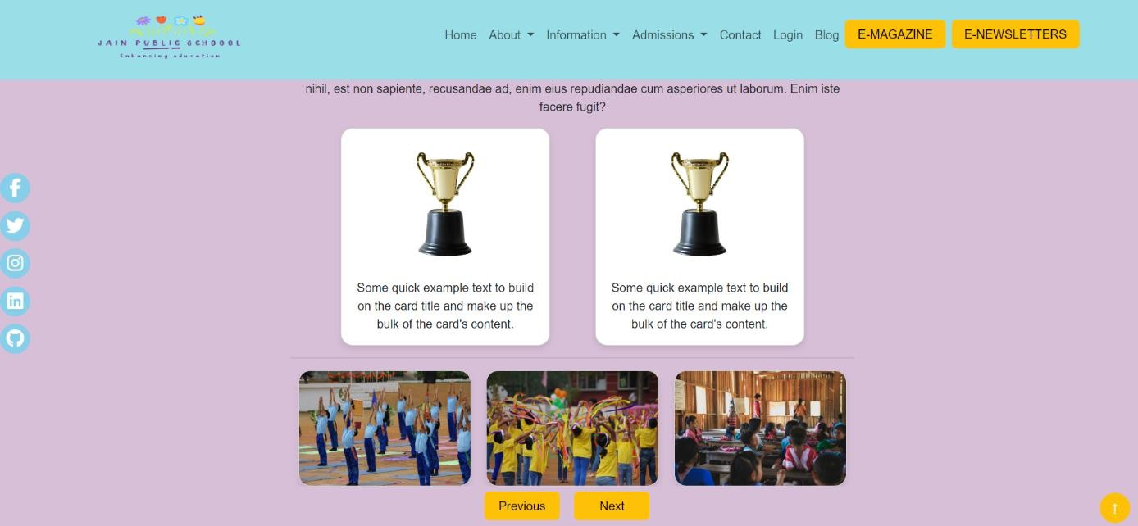

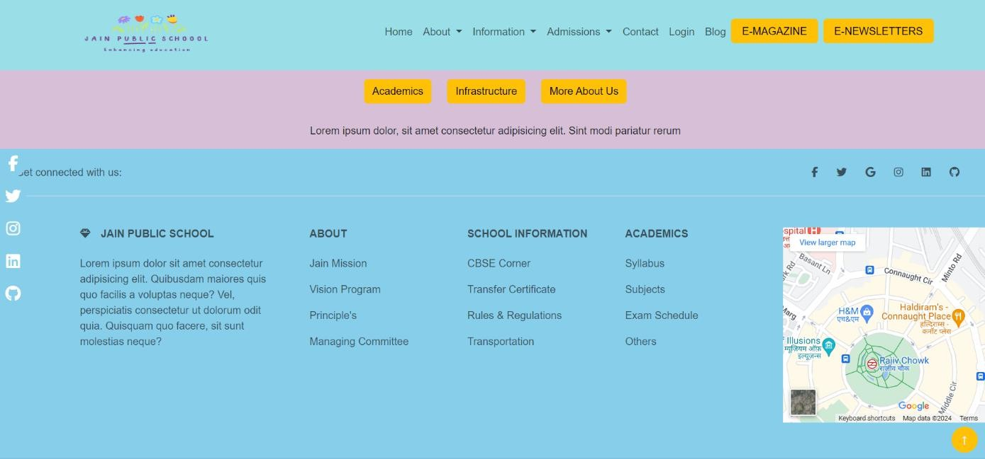

### Real Estate Web Application

The real estate web application was created to provide a robust platform for listing properties and managing client interactions, addressing the inefficiencies of traditional methods.

**Property Listings:** We developed a comprehensive property listing interface where real estate agents can easily add and update property details. Each listing includes high-quality images, detailed descriptions, location maps, and other relevant information to provide potential buyers and renters with a complete view of the properties available.

**User-Friendly Search Functionality:** The platform features advanced search functionalities that allow users to filter properties based on various criteria, such as location, price range, property type, and specific amenities. This makes it easier for users to find properties that meet their needs and preferences, enhancing their experience and satisfaction.

**Lead Management System:** To improve the efficiency of managing client interactions, we integrated a robust lead management system. This system tracks all client interactions, including inquiries and follow-ups, ensuring that agents can manage leads effectively and avoid missed opportunities. It also allows agents to set reminders and track the status of each lead, facilitating timely and organized follow-ups.

**Transaction Management:** The application includes tools for managing transactions digitally. This feature supports digital document signing and secure payment processing, streamlining the transaction process and reducing the need

for in-person meetings and physical paperwork. This not only speeds up the process but also enhances security and reduces the risk of errors.

**Responsive Design:** Ensuring a seamless experience across different devices was a priority. The web application is fully responsive, providing an optimal viewing experience whether accessed from a desktop, tablet, or smartphone. This responsiveness is crucial for users who need to access property listings and manage transactions on the go.

**Scalability:** Like the school management system, the real estate web application was designed to be scalable. It can handle an increasing number of listings, users, and data without compromising performance, ensuring that the platform can grow alongside the business.

By focusing on these key aspects, we developed robust, efficient, and user- friendly web applications for both the school management system and the real estate platform. These solutions not only address the inefficiencies of traditional methods but also enhance overall operational efficiency, user satisfaction, and scalability.



### Structural Testing

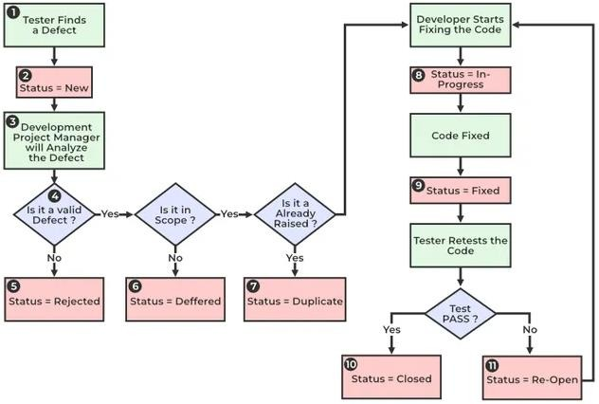

**Unit Testing**

**Description:** Testing individual components or modules of the software to ensure they perform as expected.

**Objective:** Verify that each unit of the software works correctly in isolation. **Techniques:** Use of frameworks like Jest for React.js components to test functions, methods, and classes.

Integration Testing

**Description:** Testing the interaction between integrated modules or components to ensure they work together as expected.

**Objective:** Verify that integrated modules communicate and function correctly as a whole.

**Techniques:** Use of tools like Enzyme for React.js to test how components

### interact with each other. System Testing

**Description:** End-to-end testing of the complete system to verify that it meets specified requirements.

**Objective:** Verify that the entire system functions correctly and meets all specified requirements.

**Techniques:** Use of tools like Selenium for automated testing of web applications.

### Acceptance Testing

**Description:** Validating the system with user requirements to ensure it is ready for deployment.

**Objective:** Confirm that the system meets all user requirements and is acceptable for delivery.

**Techniques:** User acceptance testing (UAT) where users or stakeholders validate the system against their needs.

### Levels of Testing Unit Testing

**Description:** Testing individual modules for functionality.

**Objective:** Ensure that each module of the software performs as designed.

**Techniques:** Use of unit testing frameworks like Jest, JUnit, or NUnit. Integration Testing

**Description:** Testing the interaction between integrated modules.

**Objective:** Verify that integrated modules work together as expected. **Techniques:** Use of integration testing tools like Postman for APIs or Selenium for web applications.

### System Testing

**Description:** End-to-end testing of the complete system.

**Objective:** Verify that the entire system meets specified requirements. **Techniques:** Use of system testing tools like TestComplete or Ranorex. **Acceptance Testing**

**Description:** Ensuring the system meets business requirements.

**Objective:** Confirm that the system meets all user and business requirements.

**Techniques:** Use of acceptance testing tools like Cucumber or FitNesse.

### Brief Description of Work Done

During my training, I worked on:

Developing the front-end of the school management system and real estate web application.

Implementing responsive design using HTML, CSS, and JavaScript. Building dynamic user interfaces with React.js.

Conducting various levels of testing to ensure quality and performance.xdc



**Reference.**

<https://www.javatpoint.com/> <https://stackoverflow.com/> <https://www.wikipedia.org/> <https://www.geeksforgeeks.org/> <https://www.frontendmentor.io/>